**Practical No.02**

1. **Using Packet Tracer, create a basic network of two computers using appropriate network wire. Use Static IP address allocation and show connectivity.**

**1)Add Pc0:**

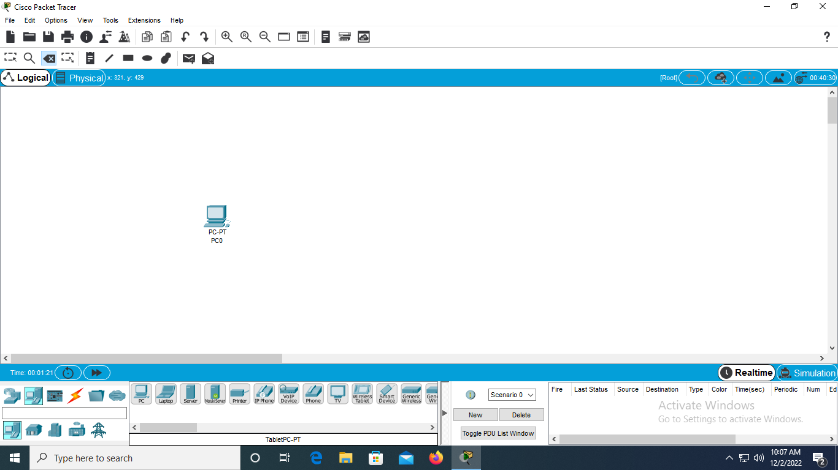

**Ip Address:**

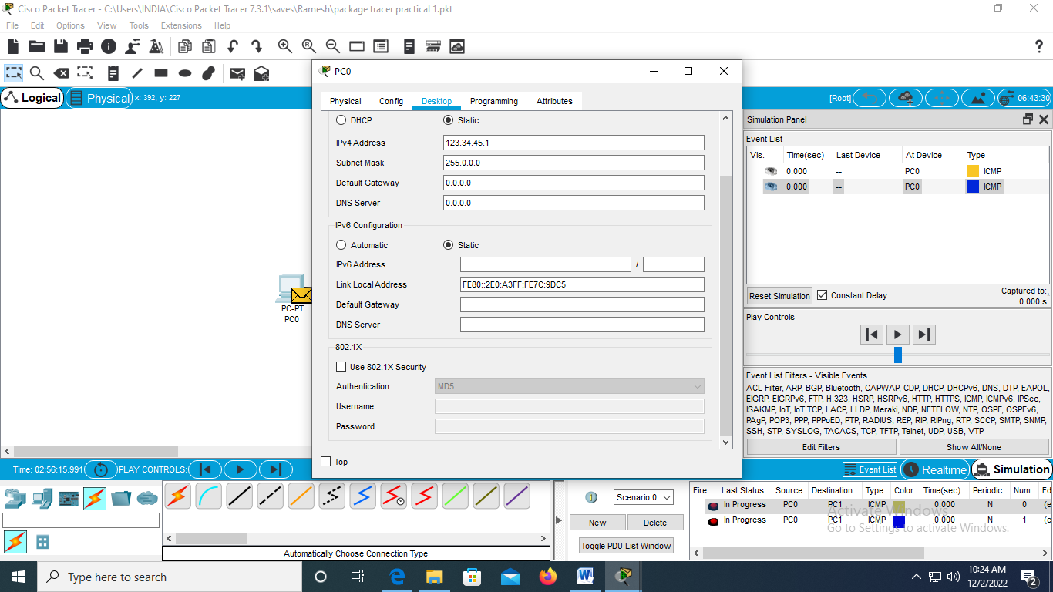

**2)Add Pc1:**

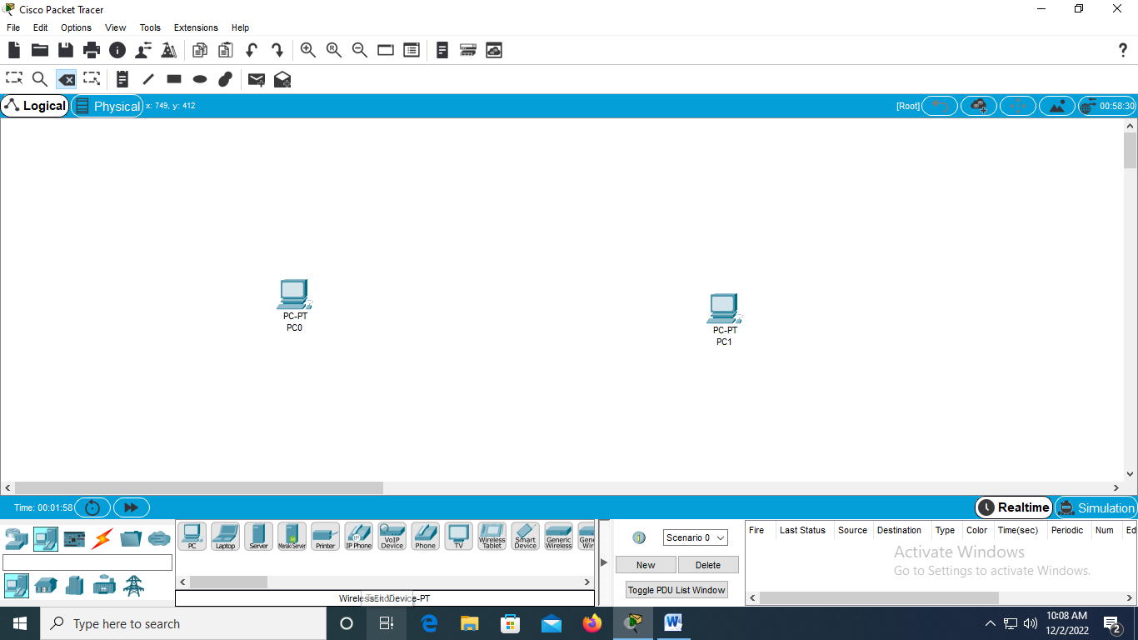

**Ip address:**

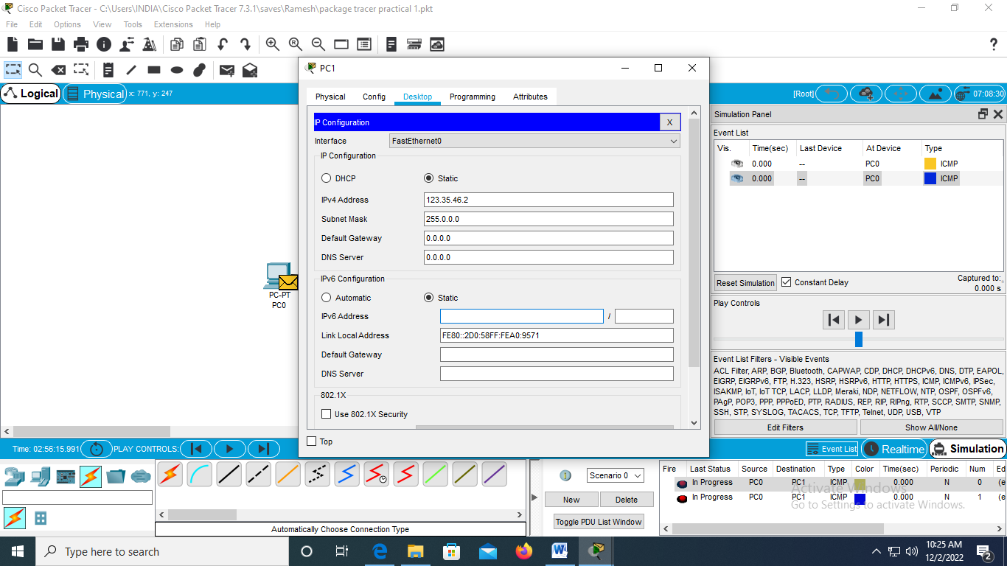

**3)Add Wire:**

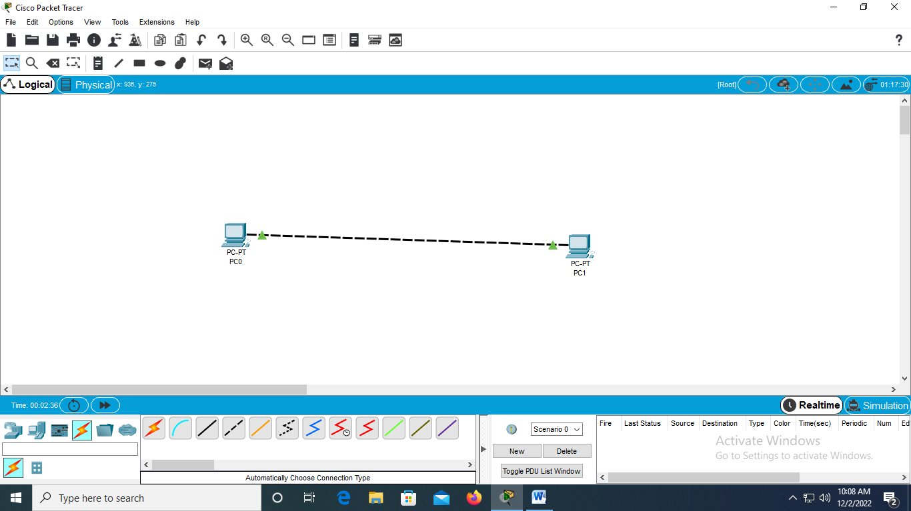

**4)Add mail with successful:**

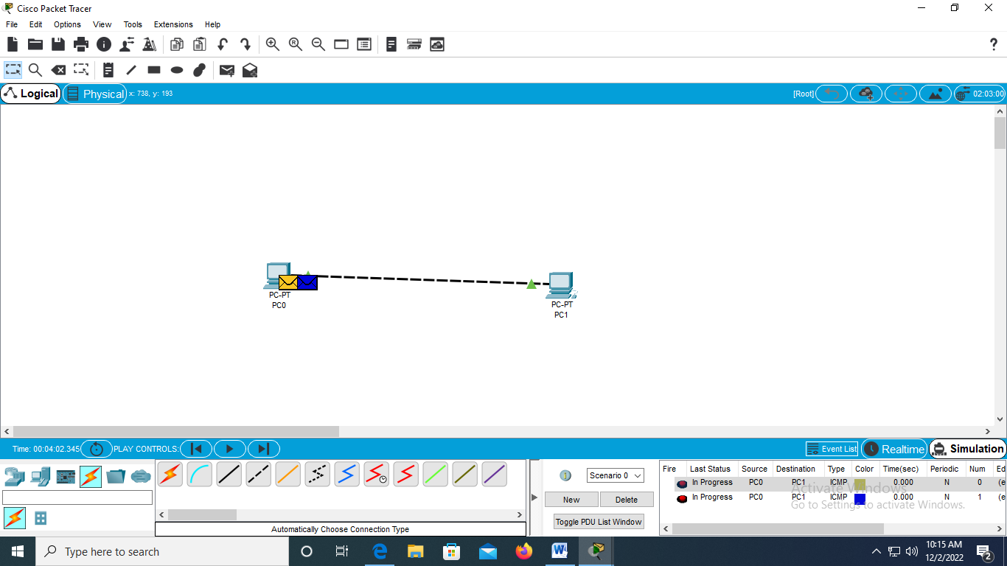

**5)Simulation:**

